FMLA and Maternity Leave

Ashley E. Henrikson

Arizona State University

Evanston, Illinois

Abstract

Maternity leave and FMLA laws are not giving expecting mothers the ability to cherish the first weeks/months with their baby comfortably. As a result, this is causing constant heartache throughout the lives of many families. Employers should step up and help make change for the community of women who have and will fall victim to the poor excuse of a “maternity” leave. Currently, FMLA states that a woman Is allowed up to twelve weeks, un-paid with job protection. The issue with giving a mom of a new baby time off with no pay, is that a new baby is expensive. There are a lot of things a woman needs to get when having a newborn even after giving birth. Along with a beautiful child comes many expenses. In addition to expenses, twelve weeks is not a very long time to bond with a new baby. Studies show that attachment can decrease the mortality rate among infants and it can also create a bond between mom and baby that can sooth baby in times of distress which will promote health in baby (Hwang, 2016). Moreover, what most people don’t know is that if your employer only offers standard FMLA by law, while you’re on leave there is a chance you can still be terminated. Even though FMLA states that you receive job security, there are provisions in which you could be dismissed if you are not considered a key employee and you are not in the top 10% of highest paid employees (Beckett, 2016).

FMLA states that an expected mother is allowed 12 weeks unpaid leave with job security upon return. What you may know about this might change after knowing that you really aren’t granted job security. Now yes, there are laws against discrimination and treating women who are pregnant or on leave fairly is included but unfortunately rules aren’t always followed. Between 1992 and 2006 alone the charged filed for pregnancy discrimination have gone up more than half (see figure 1). If the company you work for does decide to terminate you they at least need to give you the opportunity to return to work. These practices are terrible and can cause a woman, who is supposed to be sharing this special time with her new baby must now worry about whether she can provide. This is an issue that needs to be resolved for the sake of the economy and community.

Figure 1

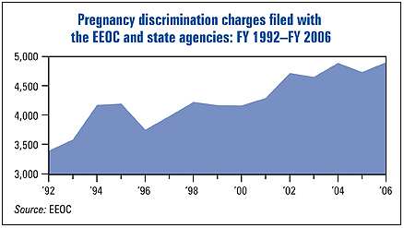

When you look at the number of women whom go back to work just a short time after giving birth you have to wonder, is she the soul bread winner? If you look at figure 2, you can see that in 2014 girls between the ages of 15 and 19, and women between the ages of 20 and 24 had given birth while unmarried. That would leave us to assume that these women ages 18-24 whom are no longer minors, are the soul breadwinner for themselves and their child. The federal government only see’s necessary to give women twelve weeks unpaid leave while France gives twenty weeks paid leave and Germany gives 42 weeks paid leave. As you can tell, our employers need to be the voices to help the government pick up with the times and see the health and wellness benefits of a proper maternity leave policy.

Figure 2

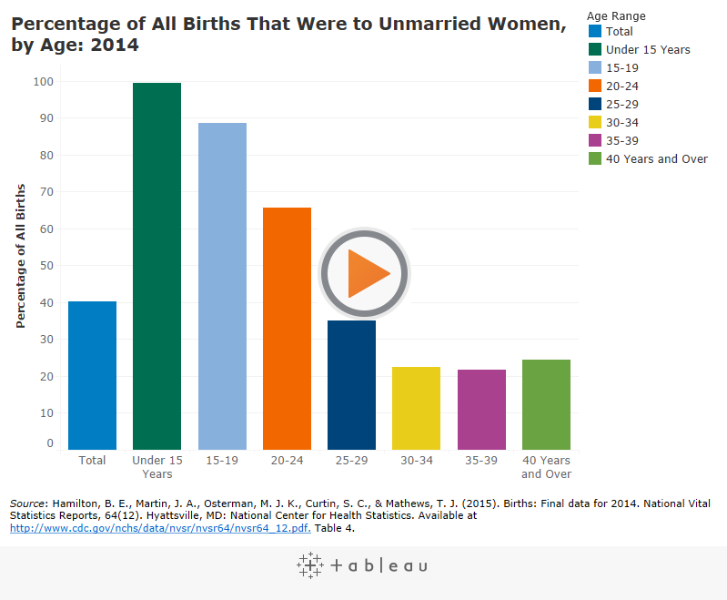

A mother’s maternity leave isn’t just about her health and wellbeing, it’s also about baby’s health and wellbeing. According to Hwang, researchers in the West have shown that paid maternity leave, among other work–family policies, is effective both for increasing the fertility rate among working women and for improving children's wellbeing (Hwang, 2016). With this information we know that changing the FMLA/Maternity leave policies can benefit all involved. It’s important to understand the attachment a child has to its mother when first born. Stripping a six week old or a twelve week old baby from his/her mother and placing her in the hands of strangers while mom is away at work is not at all beneficial for baby’s growth and development. Processing this information, I think it’s fair to say that providing what’s healthiest for the new baby should be the priority, not the employers policies and demands. Ensuring the child is positively stimulated mentally, physically, and emotionally will benefit the community as a whole in the long run.

In conclusion, its imminent that we change the FMLA/Maternity leave provisions to better suit the needs of women and their children, to promote their health and development. Employers should make change for the community but also for the women whom are the soul breadwinners for their family married and unmarried. Considering that other countries in Europe give their expecting mothers 20-42 weeks off, its only right that we see the studies that show how important maternity leave really is, and make a change.

References

Source 1.

Hwang, W., & Jung, E. (2016). Does Paid Maternity Leave Affect Infant Development and Second‐Birth Intentions? Family Relations, 65(4), 562-575.

Source 2.

Aitken, Garrett, Hewitt, Keogh, Hocking, & Kavanagh. (2015). The maternal health outcomes of paid maternity leave: A systematic review. Social Science & Medicine, 130, 32-41.

Source 3.

Johnson, J. O., Downs, B., & Bureau, U. C. (2005). Maternity leave and employment patterns of first-time mothers, 1961-2000. Washington, D.C.]: Washington, D.C.: U.S. Dept. of Commerce, Economics and Statistics Administration, U.S. Census Bureau.

Source 4.

Beckett, J. (2016, May 16). Illinois (IL) Maternity Leave Law Explained | Labor Law Education Center: Learn About Labor Laws in Your State. Retrieved from https://www.laborlawcenter.com/education-center/illinois-il-maternity-leave-law/

Source. 5

FMLA/Maternity Leave Survey on Survey Monkey

<https://www.surveymonkey.com/r/DGGY2D5>

Multimodal Figure 1

Home. (2017). Retrieved from <https://www.thehrspecialist.com/5332/pregnancy-maternity-leave-a-legal-guide-and-sample-policy>

Multimodal Figure 2

Chatterji and Markowitz. (2012). The maternal health outcomes of paid maternity leave: A systematic review. Retrieved from http://www.sciencedirect.com.ezproxy1.lib.asu.edu/science/article/pii/S0277953615000842